06 Boilerplate press release for the official to encourage gardeners to donate (Harvest for Hunger specific)

Note: Please share your press release with Ishared@AmpleHarvest.org. We’d love to see it!

Press Release Template

Harvest for Hunger Campaign

Government Officials Encourage Gardeners to Donate Extra Garden Produce to Local Food Pantries
FOR IMMEDIATE RELEASE
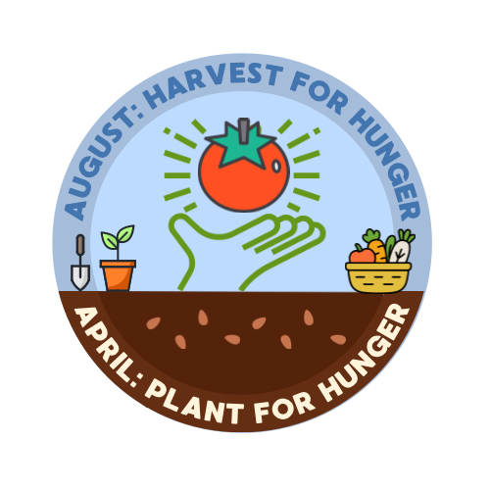
[CITY/COUNTY/STATE], [DATE] — As gardens begin producing abundant fruits and vegetables, [City/County/State Name] officials are encouraging local gardeners to donate their extra harvest to nearby food pantries through AmpleHarvest.org as part of the national Harvest for Hunger campaign.
Throughout the summer and fall, many home gardeners find themselves with more tomatoes, zucchini, peppers, beans, and other produce than they can use. At the same time, food pantries often have limited access to fresh fruits and vegetables.
“Sharing extra produce from your garden is a simple and powerful way to help neighbors facing hunger,” said [Mayor/County Executive/Governor/Health Commissioner NAME]. “Through AmpleHarvest.org, gardeners can quickly find local food pantries that welcome fresh produce donations.”
The Harvest for Hunger campaign encourages gardeners to donate surplus fruits, vegetables, and herbs throughout the growing season, helping food pantries provide healthier options for the families they serve.
“Fresh produce is one of the most requested items at food pantries,” said [Official Name]. “By donating extra harvest, gardeners can help bring nutritious food to people who need it most.”
Gardeners can find nearby food pantries accepting fresh produce donations by visiting:
www.AmpleHarvest.org
Food pantries that would like to receive produce donations are also encouraged to register on the website.

About AmpleHarvest.org
AmpleHarvest.org is a nationwide nonprofit organization that connects gardeners with local food pantries to donate surplus harvest. By making it easy to share extra garden produce, the program helps increase access to fresh fruits and vegetables for people facing hunger while reducing food waste.

Media Contact
[Name]
[Title]
[Department/Office]
[Phone]
[Email]

