05 Boilerplate press release for the official to encourage gardeners to donate (Plant for Hunger specific)

Note: Please share your press release with Ishared@AmpleHarvest.org. We’d love to see it!

Press Release Template

Plant for Hunger Campaign

Government Officials Encourage Gardeners to Plant a Little Extra to Help Feed Local Families
FOR IMMEDIATE RELEASE
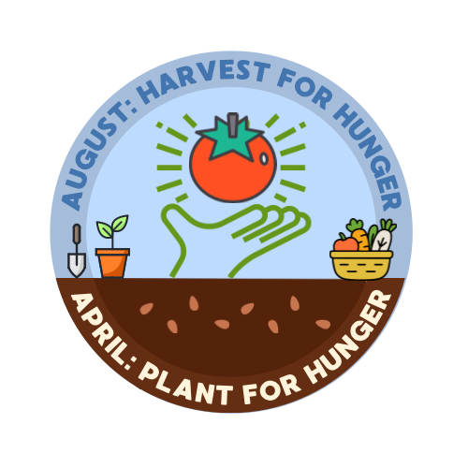
[CITY/COUNTY/STATE], [DATE] — As spring planting season begins, [City/County/State Name] officials are encouraging residents to plant a little extra in their gardens this year to help feed neighbors in need through AmpleHarvest.org and the national Plant for Hunger campaign.
The initiative asks home gardeners to dedicate a small portion of their garden to growing extra fruits, vegetables, or herbs that can later be donated to local food pantries.
“Many gardeners find that they harvest more food than their families can use,” said [Mayor/County Executive/Governor/Health Commissioner NAME]. “By simply planting a little extra, residents can make a meaningful contribution to families in our community who may not have regular access to fresh produce.”
Across the country, millions of home gardens produce surplus food each year, while food pantries often struggle to provide fresh fruits and vegetables to those they serve. Through AmpleHarvest.org, gardeners can easily find nearby food pantries that accept fresh produce donations.
Officials say the campaign offers a simple way for residents to help address food insecurity while also reducing food waste.
“Planting just one extra row of vegetables can help provide healthy meals for local families,” said [Official Name]. “This small act of generosity can have a big impact.”
Gardeners can learn more about the campaign and locate nearby food pantries by visiting:
www.AmpleHarvest.org
Food pantries interested in receiving donations are also encouraged to register on the website.

About AmpleHarvest.org
AmpleHarvest.org is a nationwide nonprofit that connects gardeners with local food pantries to donate surplus harvest. The program helps increase access to fresh fruits and vegetables for people facing hunger while reducing food waste in communities across the United States.

Media Contact
[Name]
[Title]
[Department/Office]
[Phone]
[Email]

