

AmpleHarvest.org/Government

Social Media Toolkit
Notes:
- Please forward a copy of any press releases to info@AmpleHarvest.org
- Please be sure to link your social media postings to AmpleHarvest.org
- Lastly, please remember to always use “AmpleHarvest.org” and never “Ample Harvest”

Promoting AmpleHarvest.org and Donating Surplus Garden Produce
This toolkit gives city, county, tribal, and state government offices simple posts they can use across social platforms.
Recommended platforms: Links
- Facebook https://facebook.com/ampleharvest.org
- Instagram https://www.linkedin.com/company/ampleharvest-org
- X https://twitter.com/ampleharvest
- LinkedIn https://www.linkedin.com/company/ampleharvest-org
- Community newsletters
Always include the website: www.AmpleHarvest.org

General Awareness Posts

Did you know many gardeners grow more fruits and vegetables than they can use?
You can share your surplus harvest with neighbors in need. Find a local food pantry accepting fresh produce through AmpleHarvest.org.
Visit: www.AmpleHarvest.org

Local gardeners can help reduce food waste and fight hunger at the same time.
If your garden is producing surplus tomatoes, zucchini, peppers, or herbs (or anything else), consider donating them to a nearby food pantry.
Find one here: www.AmpleHarvest.org

Fresh produce is one of the most requested items at food pantries.
If you have surplus fruits or vegetables from your garden, consider sharing them with neighbors in need.
Find a pantry accepting donations at www.AmpleHarvest.org

Plant for Hunger Campaign Posts
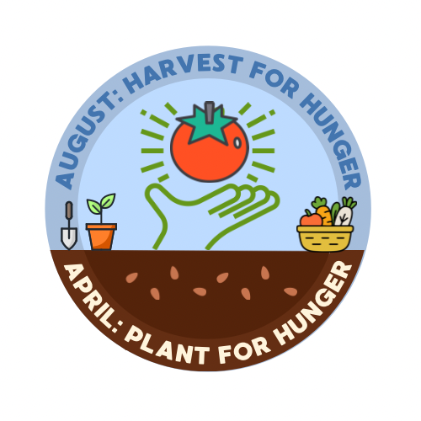
Spring planting season is here.
If you have the space, consider planting a more in your garden this year to donate to a local food pantry.
Learn how through www.AmpleHarvest.org

Plant a little extra.
Help feed a neighbor.
Join the Plant for Hunger campaign and share your garden’s bounty with local food pantries.
Find a pantry near you: www.AmpleHarvest.org

Harvest Season Posts
Is your garden overflowing with tomatoes, zucchini, or cucumbers (or anything else yummy)?
Donate your surplus harvest to a local food pantry through AmpleHarvest.org.
Find one near you: www.AmpleHarvest.org

Garden harvest season is a great time to give back.
Share surplus fruits and vegetables with local food pantries and help families in our community.
Find a pantry accepting donations: www.AmpleHarvest.org

Pantry Recruitment Post
Food pantries in our community can register to receive garden fresh produce donations from local gardeners.
Registration is free and takes only a few minutes.
Sign up at www.AmpleHarvest.org

Community Engagement Posts
Community gardens, backyard gardens, and school gardens can all help fight hunger.
Donate surplus produce to a nearby food pantry through AmpleHarvest.org.
www.AmpleHarvest.org

A small donation from your garden can make a big difference.
Share your surplus harvest with families in need by finding a local pantry through
www.AmpleHarvest.org

